DIE# 15140 (Short) – UNITED (EXTRUDER SIDE)
Pack on Green Buggy – Wrap arms in cardboard
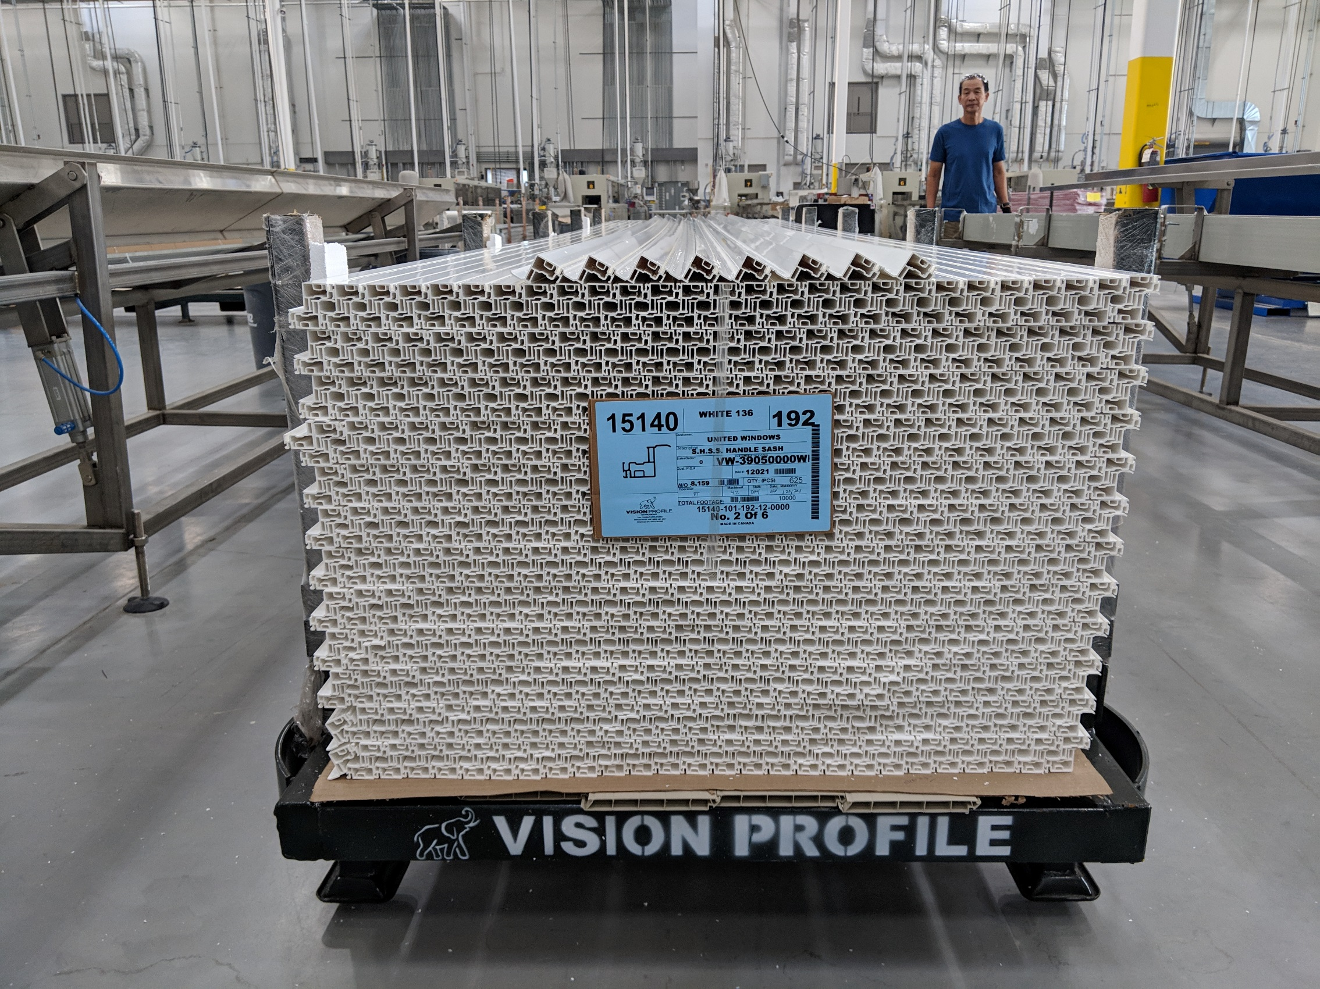
Small Foam if needed (NO FOAM FOR W/S)

